|  |
| --- |
| **Exercises from old exams to chapters in B & W.** |

|  |
| --- |
| **Chapter 6 and 8** |

**Exercise 1**

Consider a representative consumer’s choice on when to consume (today or tomorrow) for a given endowment.

1. Define the representative consumer’s indifference curves.
2. Explain by using words and a diagram a representative consumer’s optimal consumption. Define assumptions you make.
3. Use indifference curves and budget lines of a typical consumer to explain what can happen if the interest rate decreases. Define assumptions you make.

**Exercise 2**

1. Explain the household’s intertemporal budget constraint and define indifference curves in a two period’s model (consumption today and consumption tomorrow).
2. Use the model from a) to discuss countries instead of households. Suppose a country has chosen a solution along the budget line, but not optimal. Explain by using the model why this is not optimal.
3. As a follow up to b): can you name countries in such a situation and give examples of reasons why they have chosen a not optimal solution.
4. Explain the quotation: “Tax smoothing is the natural counterpart to consumption smoothing of households”.

**Exercise 3**

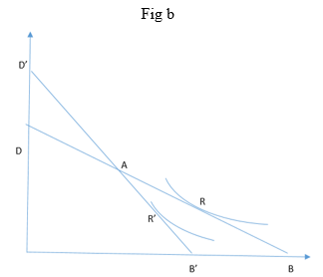The diagram (fig b) represents the household’s intertemporal budget constraint in a two period’s model.

1. Name the axes and define the line going from D to B.

1. Define point A.
2. Explain point R.
3. Explain the change of the slope of the line from DB to D’B’.
4. Explain the change from point R to point R’.
5. Suppose a household has chosen a point along line DB but not point R. Explain by using the diagram why this is not optimal.
6. If you use the diagram to discuss countries instead of households. How can you place countries at points along the line DB?